Respiratory Care Micromedex Resources
Library homepage: https://library.cod.edu/ Databases Micromedex Health Care Series
Micromedex Health Care Series provides Respiratory Care students with up-to-date drug information (monographs, drug comparisons and drug interactions), patient education materials (located in CareNotes), as well as clinical calculators.
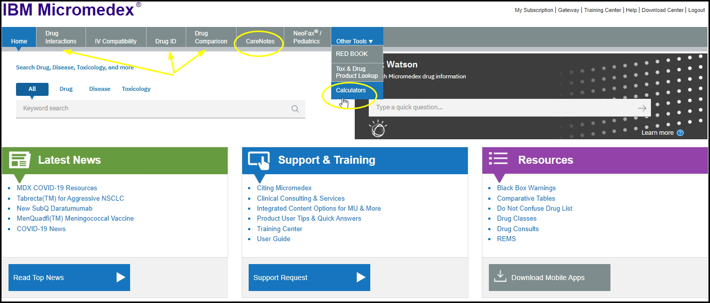
Drug Information
In addition to Micromedex serving as an online drug guide (that is updated on a daily basis as new information becomes available), this database allows you to enter medications and run interactions (drug-drug, drug-food, drug-alcohol) as well as compare drugs (e.g. you might compare two different allergy medications to see which one would be better for your patient or compare two different types of inhalers).
Clinical Calculators
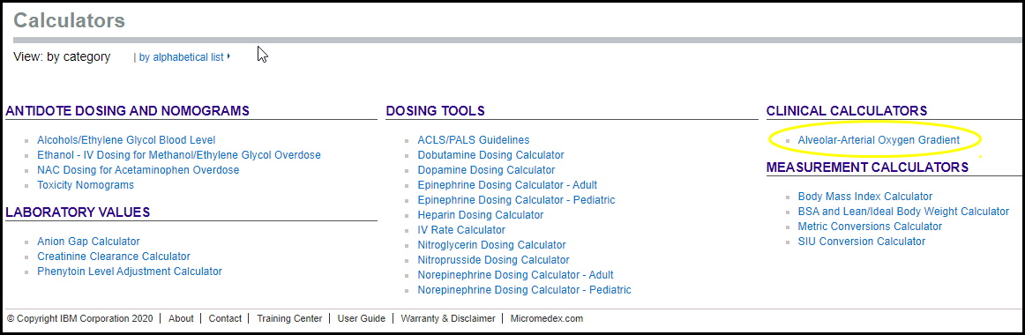
Useful clinical calculators can be found under the Other Tools tab

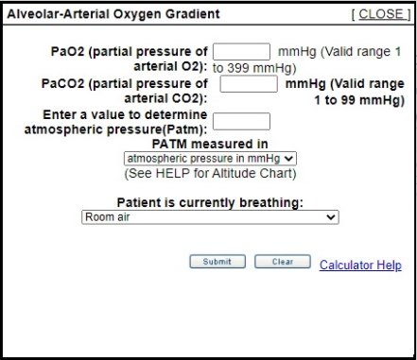

Arterial Oxygen Gradient Calculator
Note that under Measurement Calculators there are more helpful calculators including metric conversions!
CareNotes
CareNotes provides customizable patient education handouts for point-of-care (general information, discharge care (ER/ED), and ambulatory care). Handouts cover medicines, labs, care and conditions.
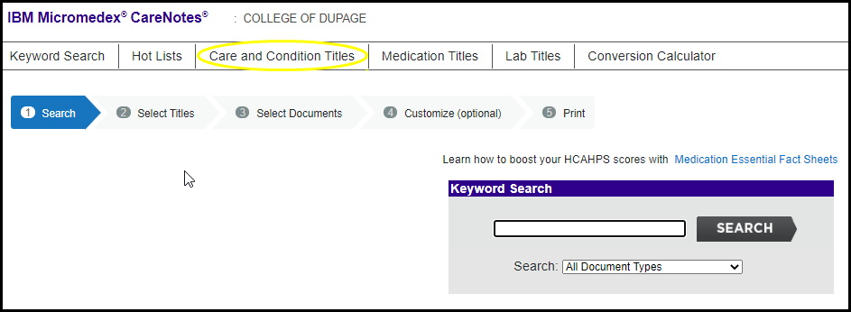
Select Care and Condition Titles and click on the Pulmonology folder for an extensive A-Z list of handouts:
